7.1.2. Possible Combinations from Three Digits
Write a Python program to accept three digits and print all possible 3-digit combinations that can be formed using those three digits. Each digit should be used exactly once in each combination.
Algorithm
- Start
- Input three values a, b, c.
- Store them in a list: digits = [a, b, c]
- Initialize loop variable i from 0 to 2.
- Inside that, initialize loop variable j from 0 to 2.
- Inside that, initialize loop variable k from 0 to 2.
- Check condition: if (i ≠ j AND i ≠ k AND j ≠ k) If true → Print digits[i] + digits[j] + digits[k]
- Repeat until all loops finish.
- Stop
Flowchart
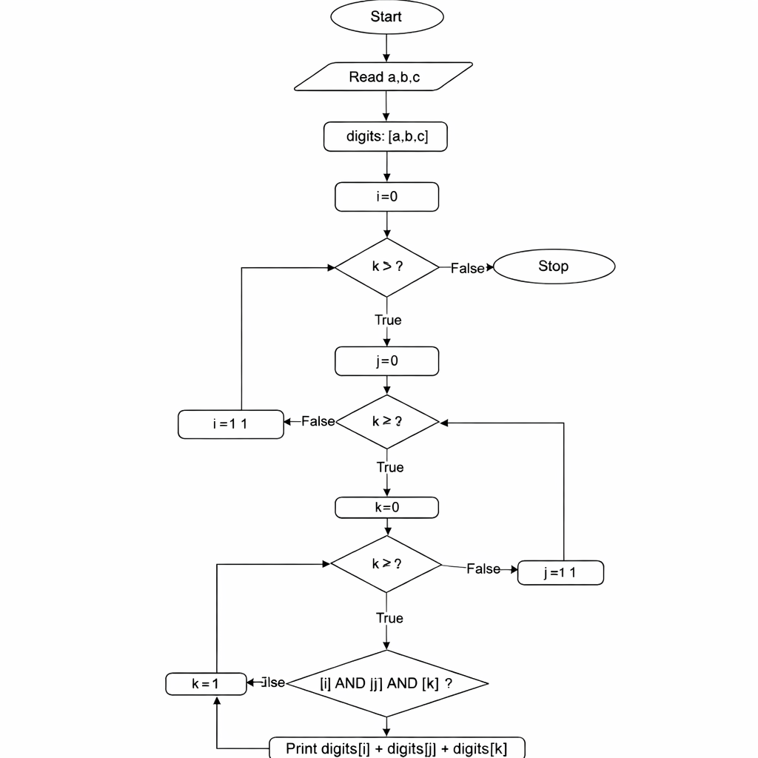
EXECUTION
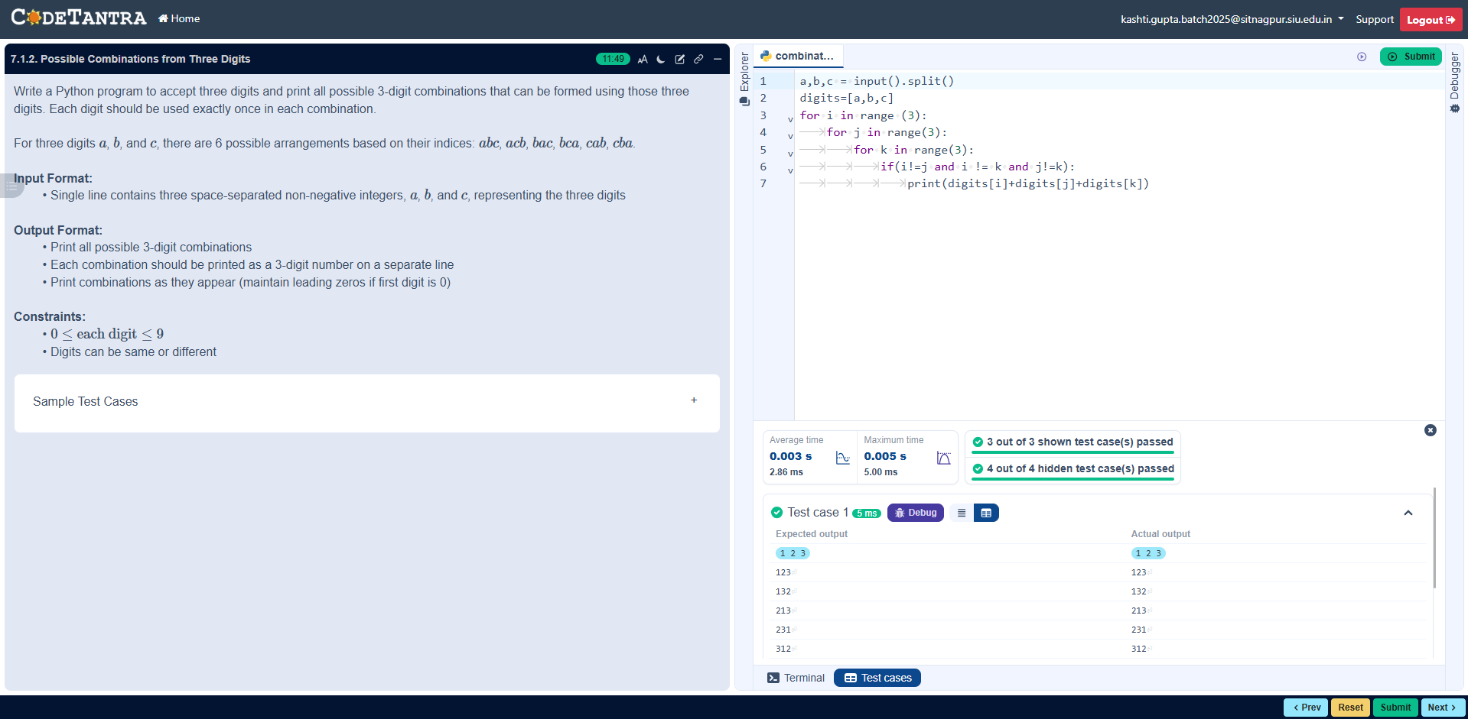

CODE
a,b,c = input().split()
digits=[a,b,c]
for i in range (3):
for j in range(3):
for k in range(3):
if(i!=j and i != k and j!=k):
print(digits[i]+digits[j]+digits[k])

